Equipment: V27 Victaulic Sprinkler Head.
Issued by: London Office | Tech-submission No.

Job Reference Number:
Project:
For the attention of:
Copy to:
From Completed By: | Stephen Keen

Manufacturer | Model | Ref. Number | Quantity
Victaulic | V27 | V2726 | 2978
Note: All equipment sourced only from LPC listed/approved contractors, where appropriate.
Equipment Particulars
Information provided: From Suppliers Data Sheets
Document Ref: Data Sheet 40.18 Attached Not Applicable
Description of application | Areas to be used
All Exposed Sprinkler Heads | All Areas
All Sprinkler Heads in Voids | All Areas

Clients specification used:
Statement of compliance to specification – Compliant not applicable
If non-compliant give details:
Status Approved Approved with comments Rejected – Re-submit
Comments:
Date Issued | Approval required by | Date approval received
00/00/2018 | 00/00/2018

Victaulic FireLock®  V27, K80  Model V2726 Convetional CU/P  Sprinkler Head. | 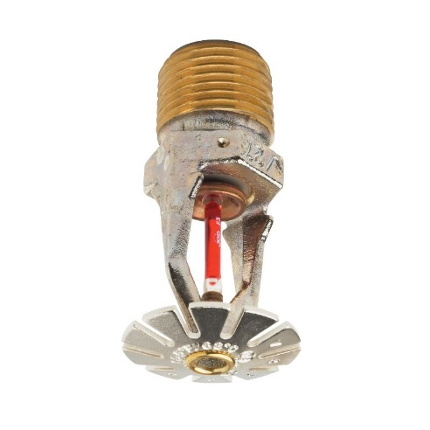

Model: | V2726
Style: | Convetional
K Factor: | 80
Nominal Thread Size: | 15mm BSP
Max. Working Pressure: | 12.5 Bar
Factory Hydrostatic Test | 100% @ 34.5 Bar
Min. Working Pressure: | 0.35 Bar
Temperature Rating: | 68°C

Product Description
These Model V27 conventional spray sprinklers are designed to produce a hemispherical spray pattern for standard commercial applications. The Model V27 convetional sprinkler is designed to produce a hemispherical pattern which deflects approximately half of the spray upwards towards the ceiling and the other half downwards and can be installed in either the upright or pendent position. It is cast with a hex-shaped wrench boss to allow easy tightening from many angles, reducing assembly effort.
Coverage
For coverage area and sprinkler placement, refer to applicable installtion standards.
Sprinkler Finishes
Plain Brass | RAL 9010 Off-White
Chrome Plated | Custom Painted
White Painted | Propriety Nickel Teflon Coating
Flat Black Painted | VC-250

Material Specification
Convetional Deflector | Bronze per UNS C51000
Bulb | Glass with glycerin solution
Bulb Nominal Diameter | Quick Response: 3mm
Load Screw | Bronze per UNS C65100
Pip Cap | Bronze per UNS C65100
Spring | Beryllium nickle
Seal | Teflon tape
Frame | Die cast brass 65-30
Lodgement Spring | Stainless steel per UNS S30200

Installation Wrench
Open End: V27 | Recessed: V27-2

Approvals/Listings
LPCB Ref. No. 104b/02
V2726 (1) 15mm CU/P
57, 68, 76, 93 & 141°C
Quick Response.

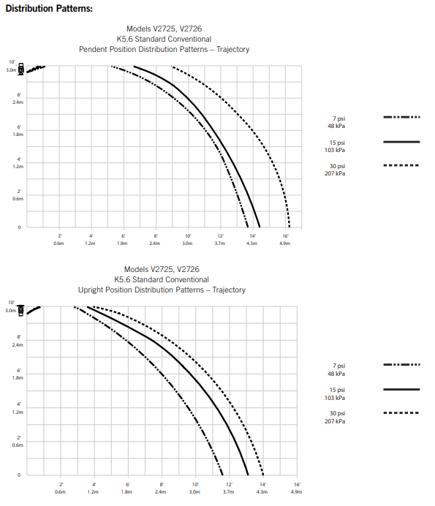
Notes:
- Data shown is approximate and can vary due to differences in intallations.
- These graphes illustrate approximate trajectories, floor wetting, and wall wetting pattens for these specific Victaulic FireLock Automatic Sprinklers. They are provided as information for guidence in avoiding obstructions to sprinklers and should not be used as minimum sprinkler spacing rules for installation.
- All patterns are symmetrical to the centreline of the waterway.
Dimentions  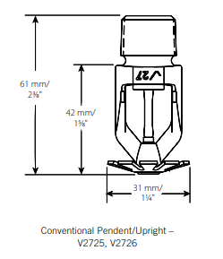 | Ratings  Sprinkler Temperature Classification Ordinary  Victaulic Prat No. C  Nominal Temperature Rating 68°C  Maximum Ambiant Temperature Allowed 98°C  Glass Bulb Colour Red

